# Weekly Report

* Schematic Design: Connection 0-ohm resistors and indicator LEDs
* Designs are multiplexed: Enumerations and Tags
* Ready for PCB design ?

## Trapping

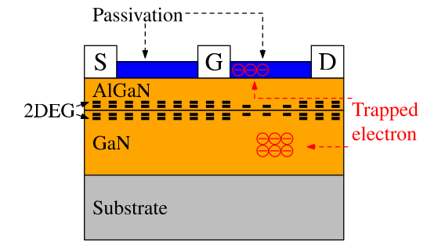

Figure 1: Trapped Electron Positions

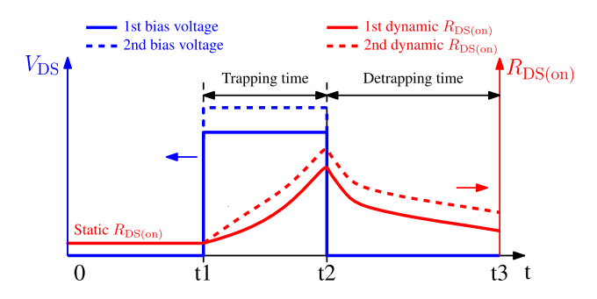

Figure 2: Trapping Time and Detrapping Time

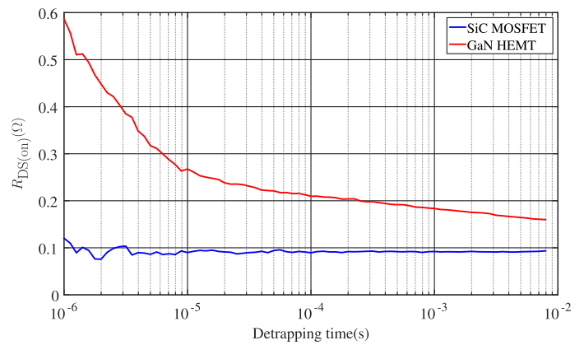

Figure : Rds-on Detrapping Period Behavior

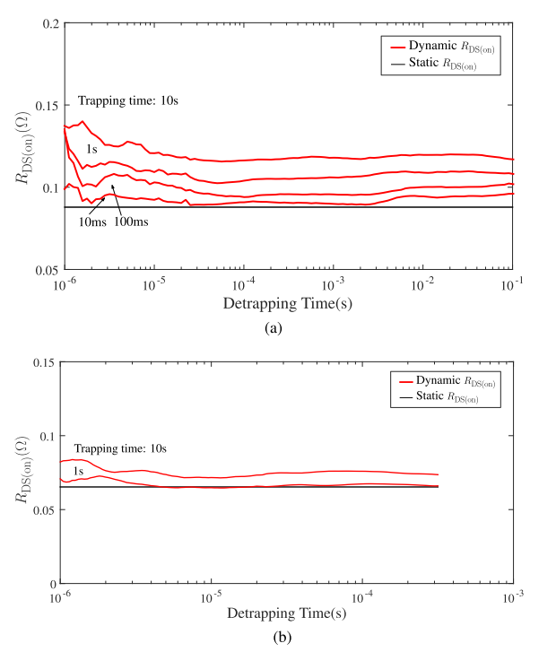

Figure : (a) is for 650V/15A GS66504B @400V bias voltage, (b) is for 100V/1A EPC2036 @100V bias voltage

